SENDING DATA FROM RASPBERRY-PI TO IBM WATSON

|  |  |
| --- | --- |
| **Date** | 7 NOVEMBER 2022 |
| **Team ID** | PNT2022TMID42892 |
| **Project Name** | GAS LEAKAGE MONITORING AND ALERTING SYSTEM FOR INDUSTRIES |

# AIM:

To send sensor data (or any dummy data) from Raspberry –Pi to IBM Watson .In our case it is DHT sensors Data.

# REQUIREMENTS: HARDWARE:

* RASPBERRY-PI (3B)(WITH ETHERNET CABLE OR WIFI CONNECTED)
* USB MOUSE
* USB KEYBOARD
* VGA TO HDMI CABLE
* A MONITOR
* RASPBERRY’S POWER SUPPLY
* DHT-11 Sensor
* Connecting Wires

# SOFTWARE:

* 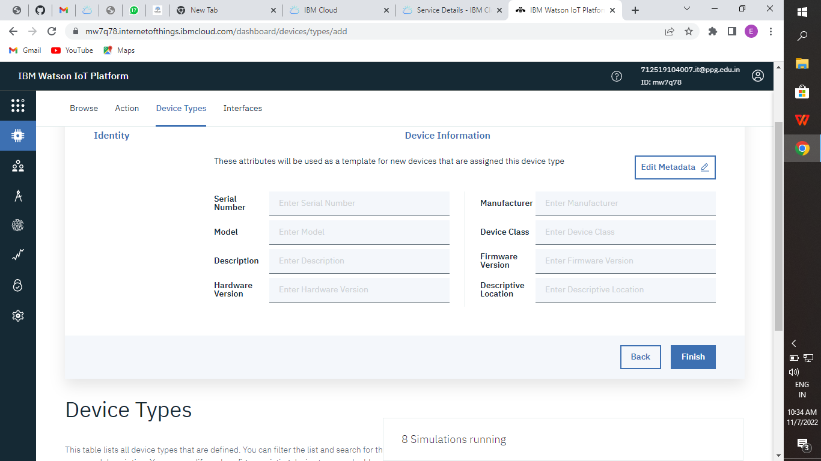IBM BLUEMIX ACCOUNT

# STEPS TO BE FOLLOWED

**Step-1: Create a device in IBM Watson:**

* Firstly, login into your IBM-Bluemix account with your e-mail ID and Password.

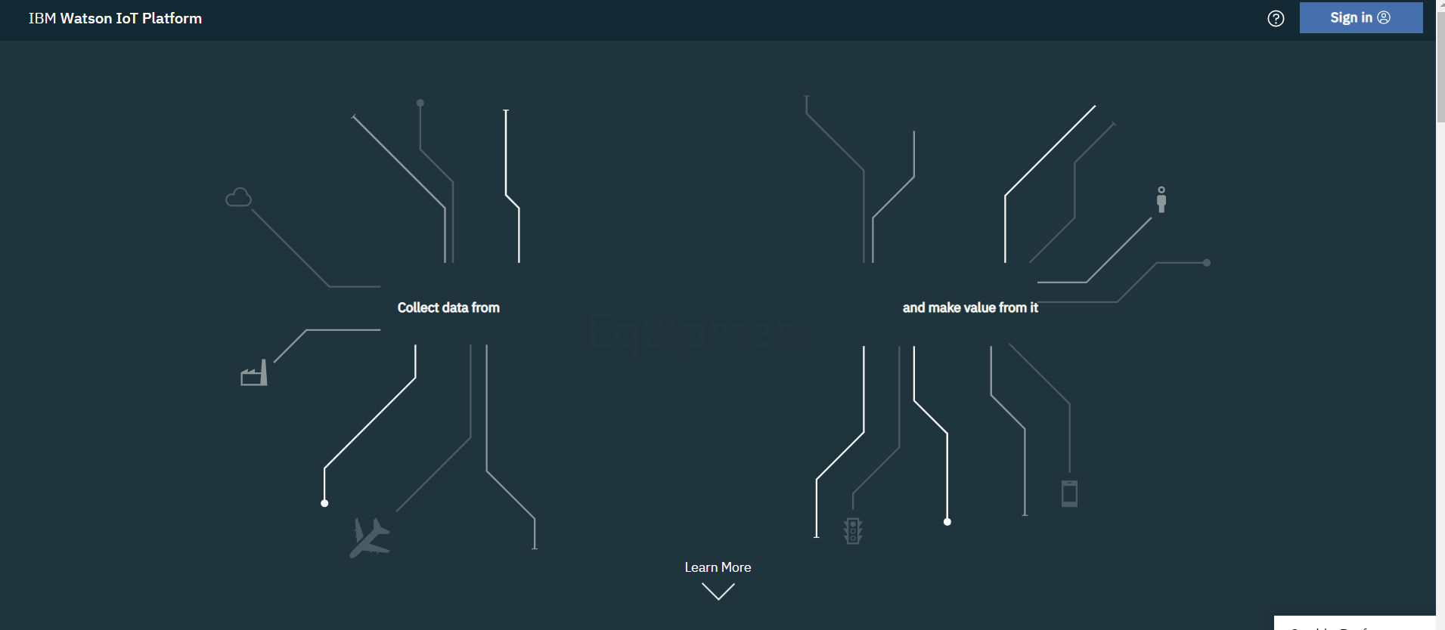

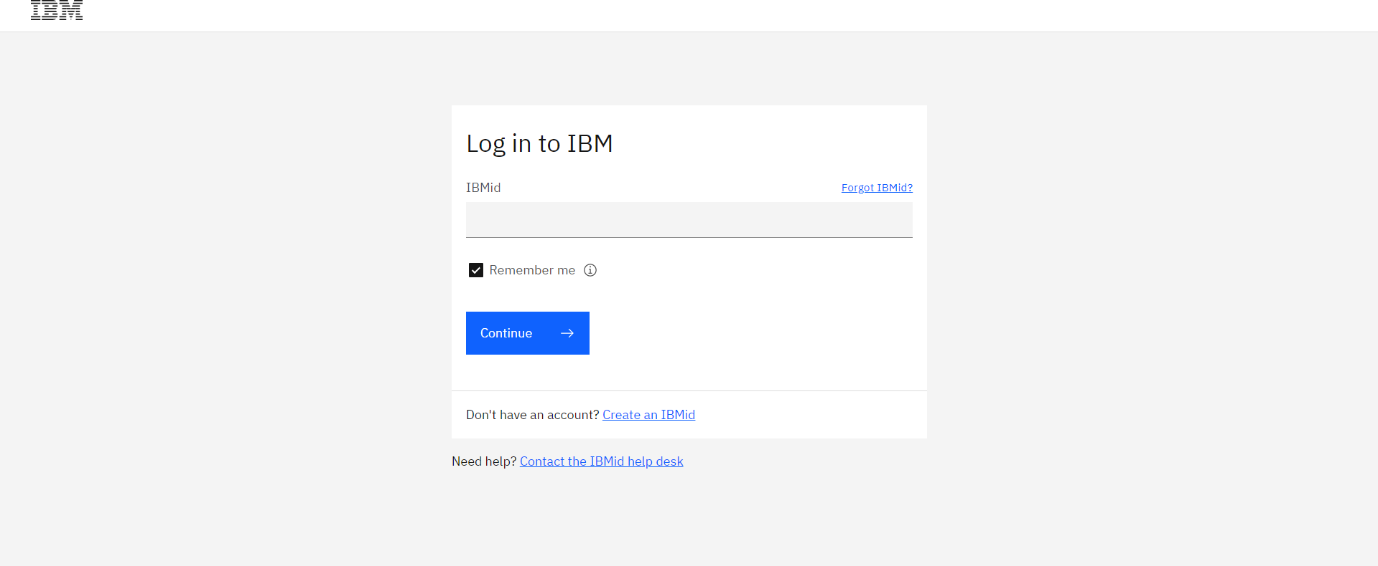

* Click on catalog on your dashboard screen, then under platform go IoT.

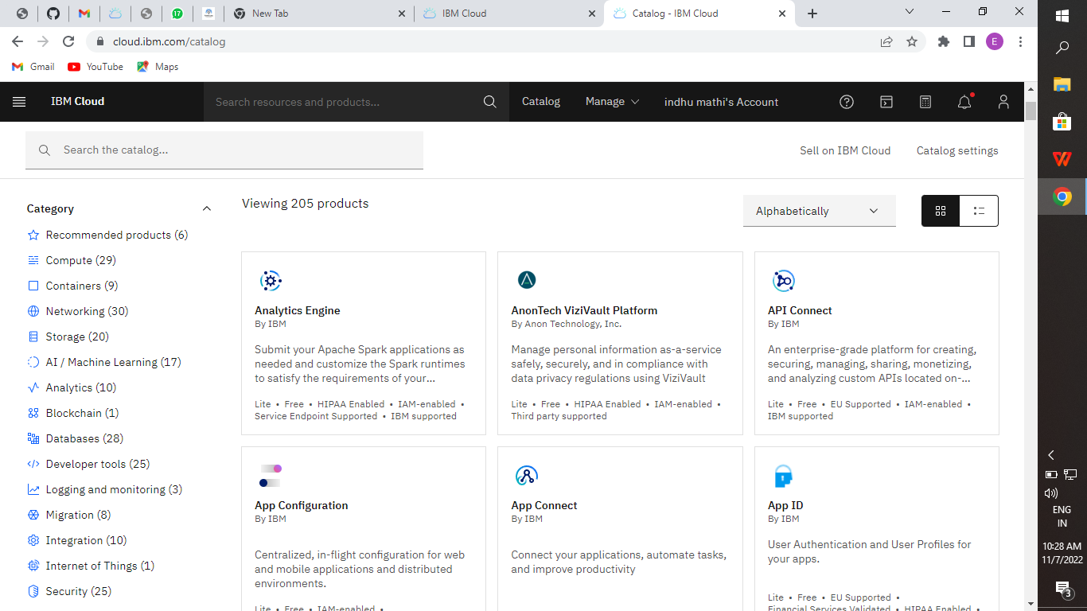

* Check all details and click on create.

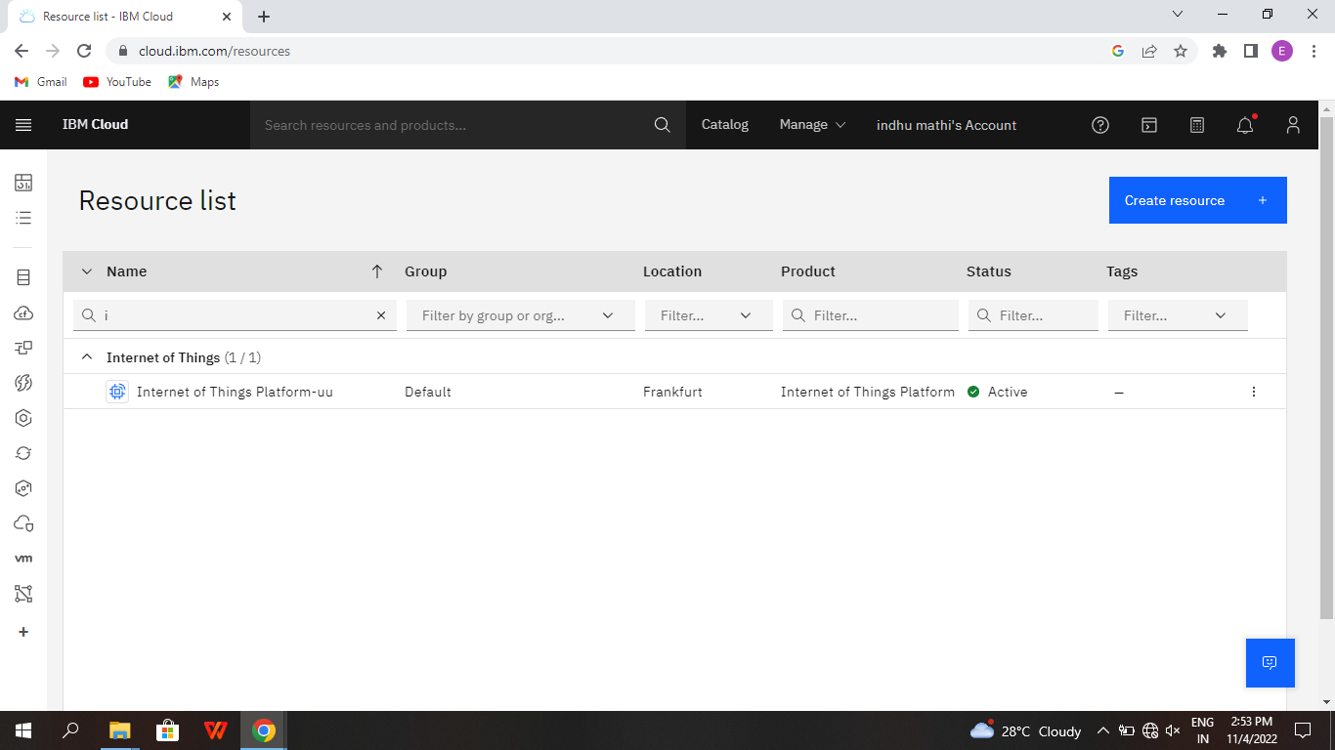

* click on Launch

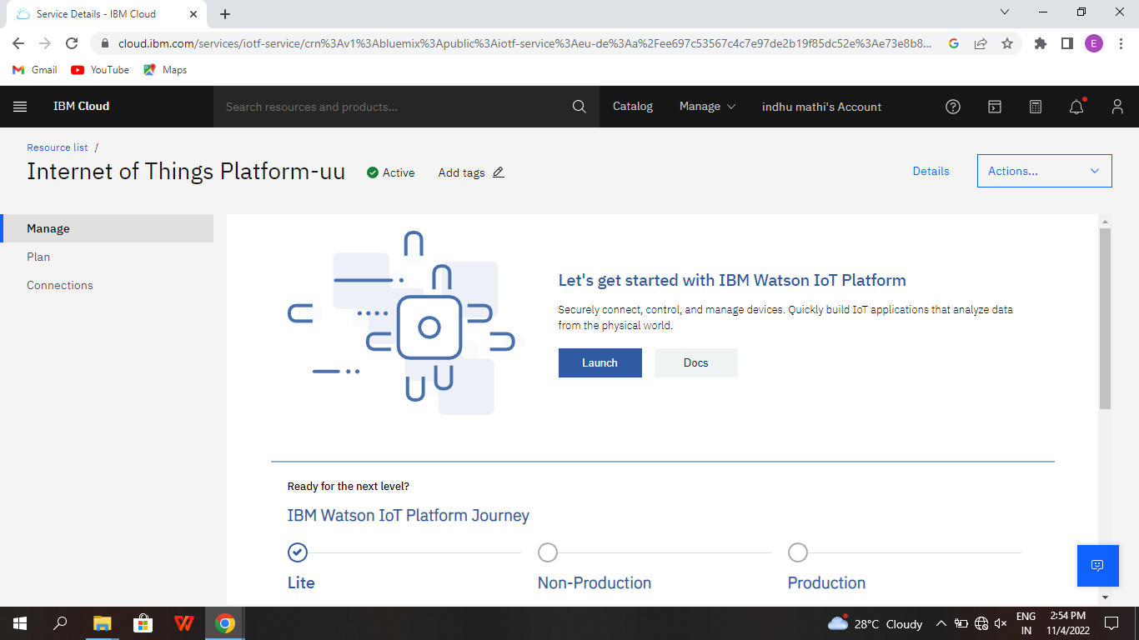

* Dashboard of IBM Watson IoT platform,
* Click on Add device

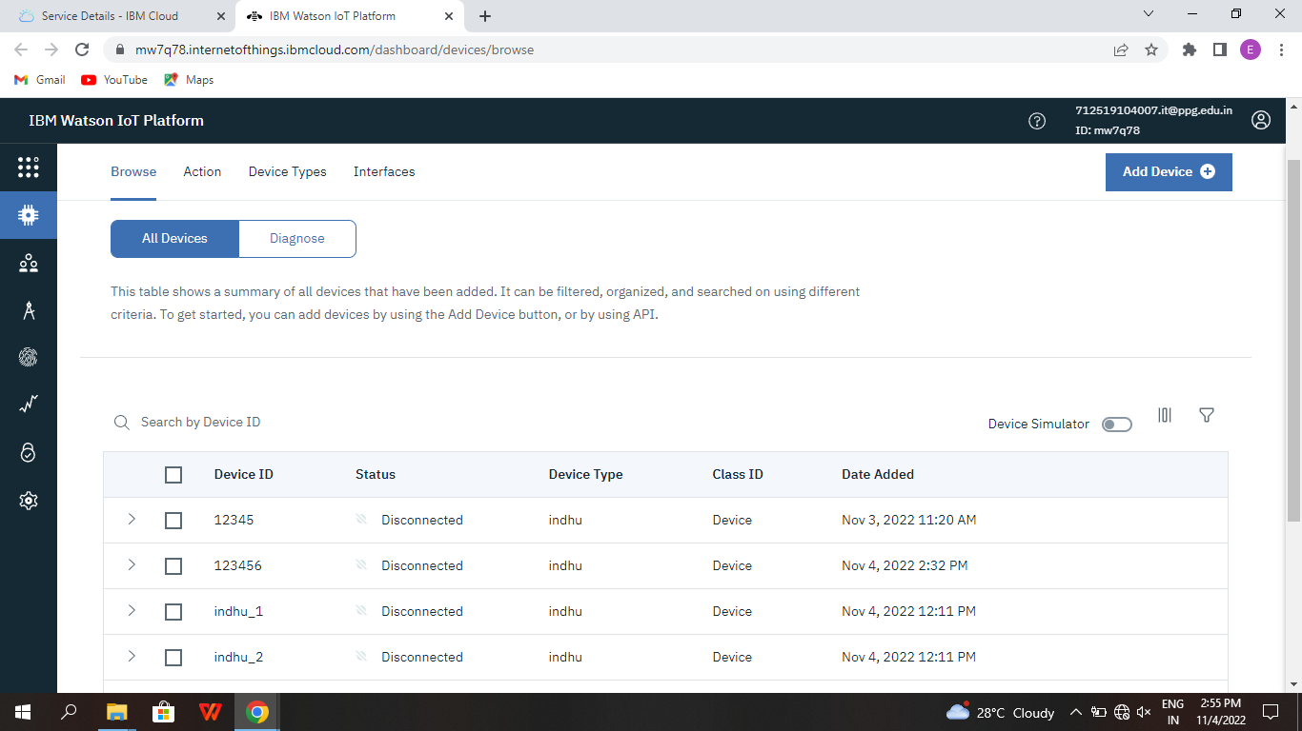

* After click on Add device this page will open

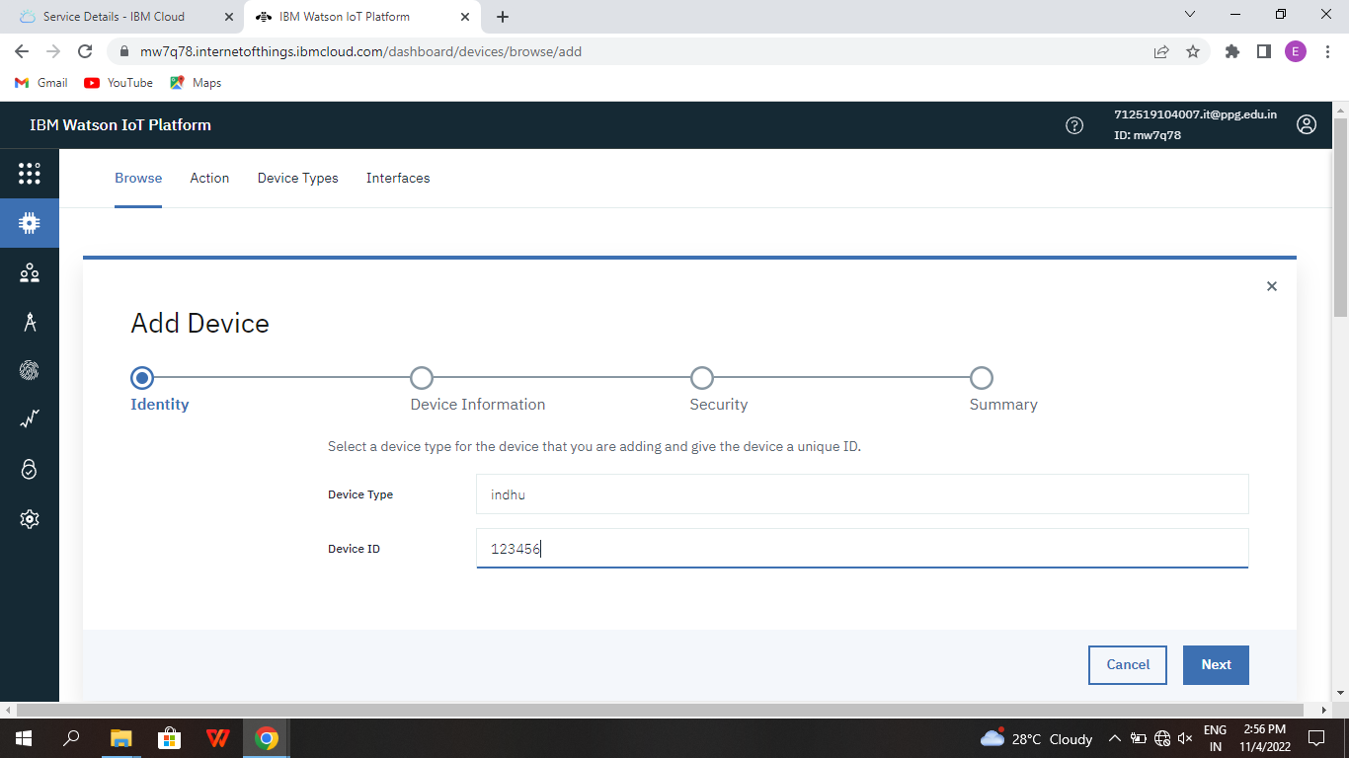

* Go to device type and fill the details.



* Click on Finish
* Click on Register Device.

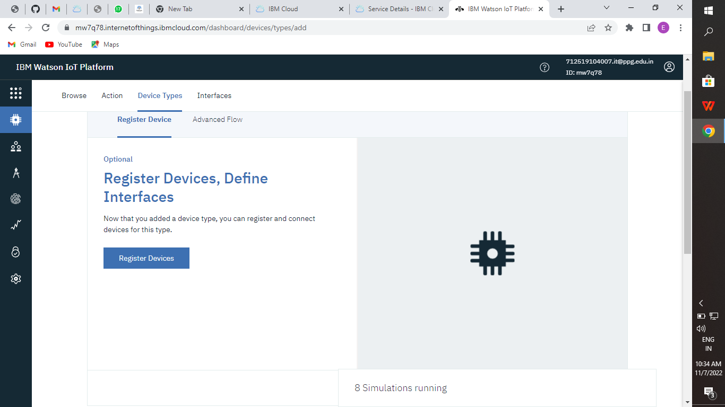

* Choose the device and give device ID and then click on next.



* Click on Next

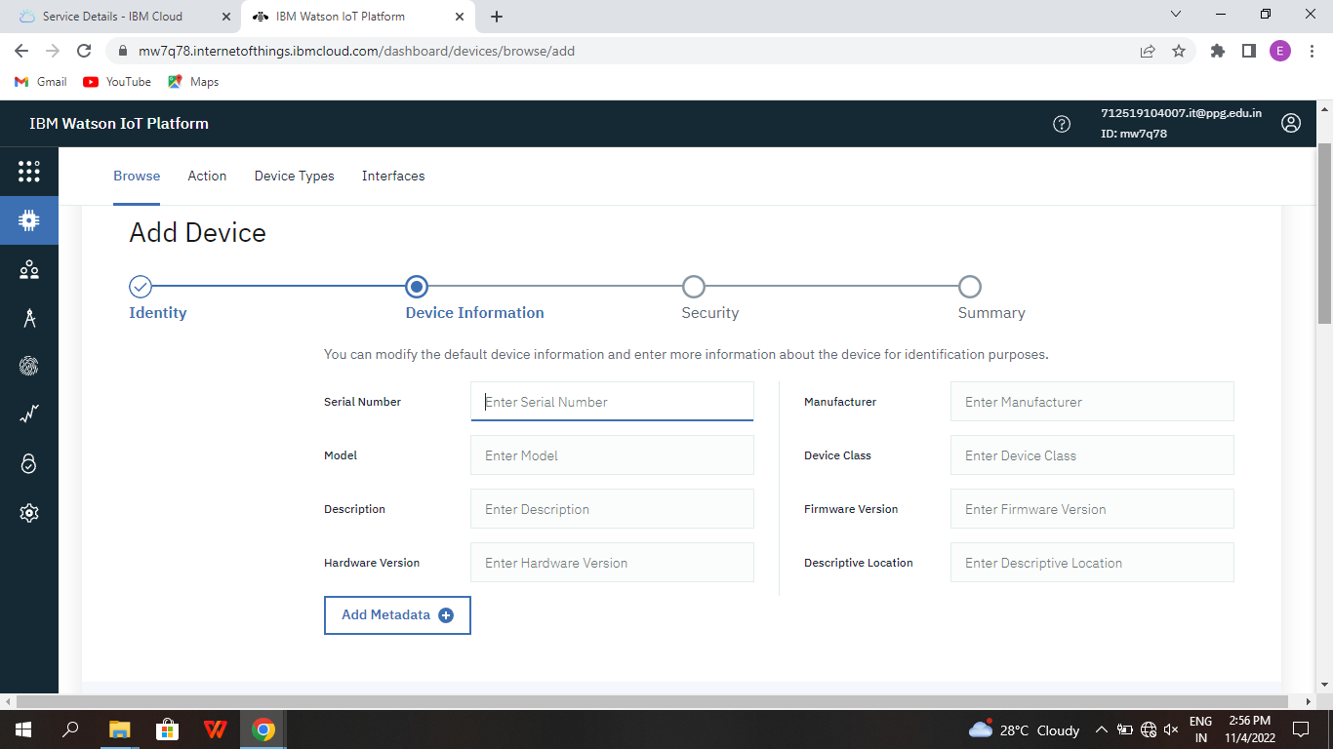

* Click on Next

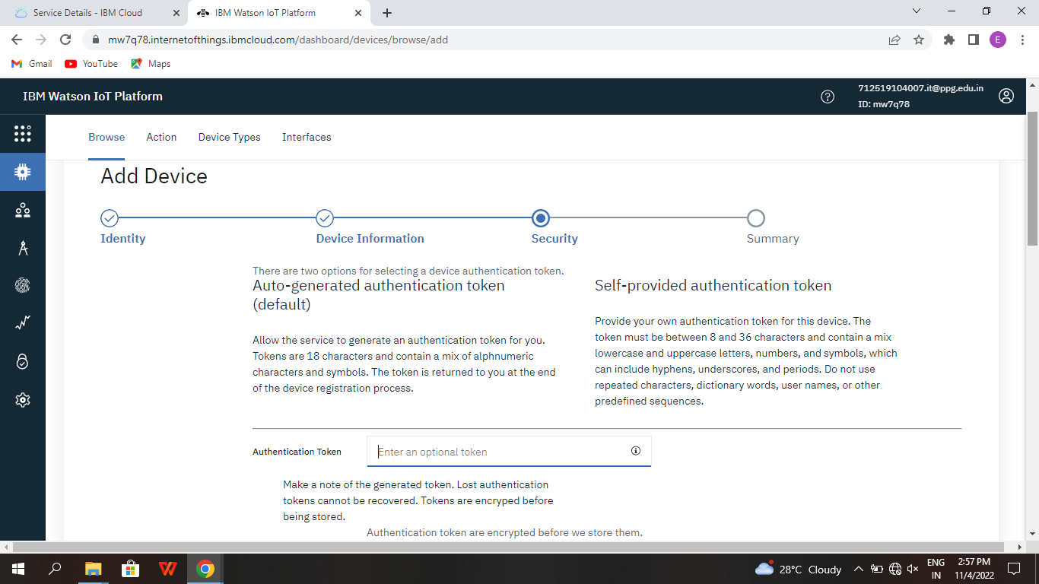

* Click on Finish

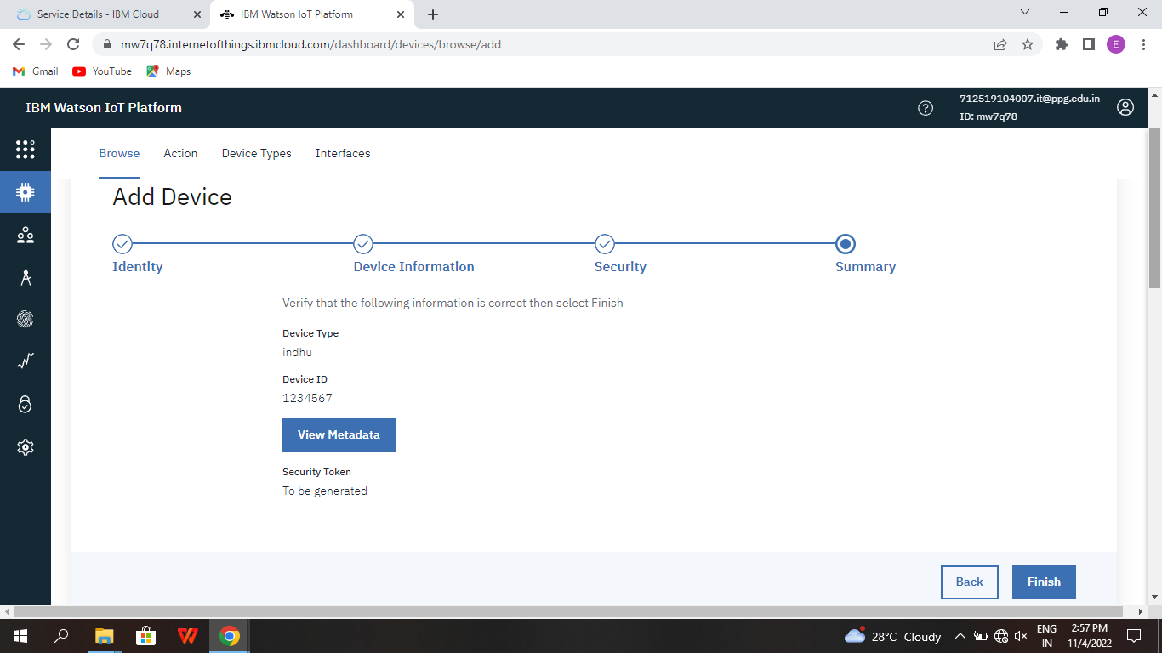

* Device is created

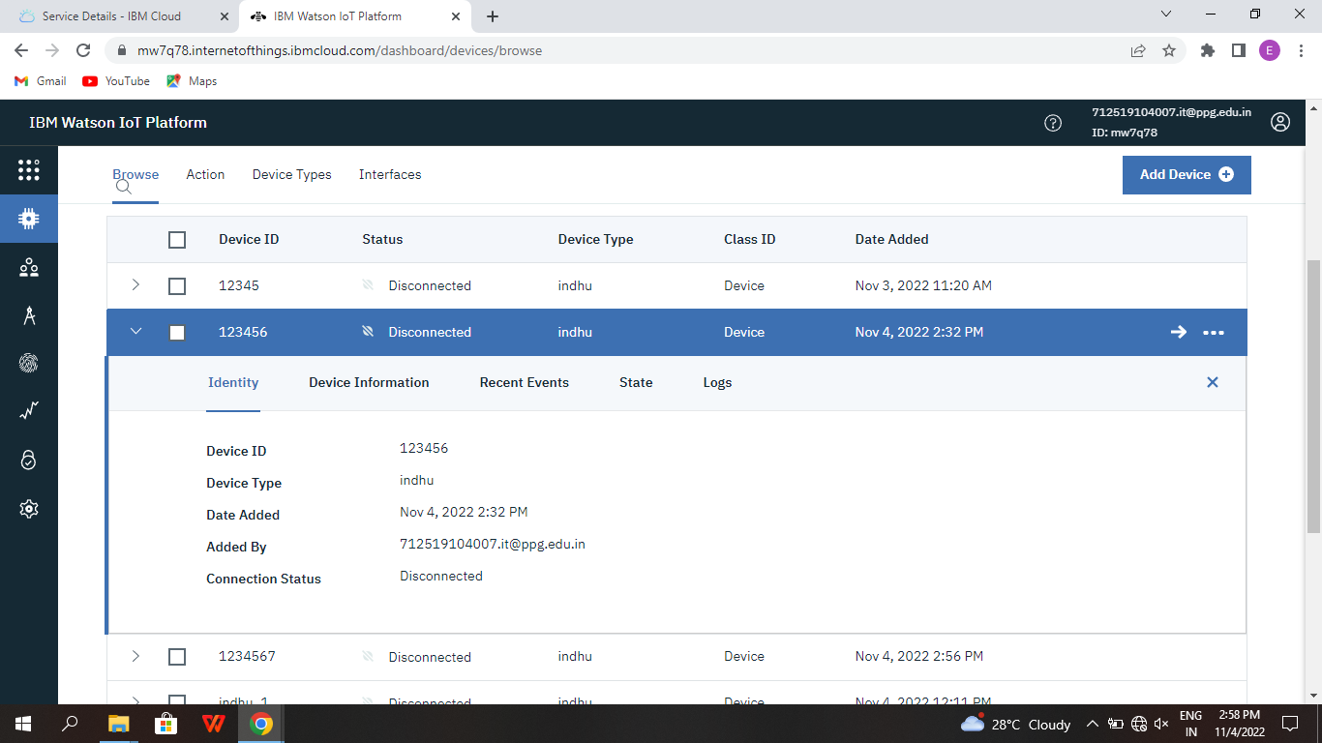

# STEP-2: INSTALLING NECESSARY PACKAGES ON YOUR PI:

* Now we are going to install necessary packages on your pi.
* Open your terminal in your pi and type the following commands
* curl -LO

https://github.com/ibm-messaging/iot-raspberrypi/releases/download/1.0.2.1/io t_1.0- 2_armhf.deb

* sudo dpkg -i iot_1.0-2_armhf.deb
* service iot status

Following are the images as to what appears on your pi’s terminal when u type these commands

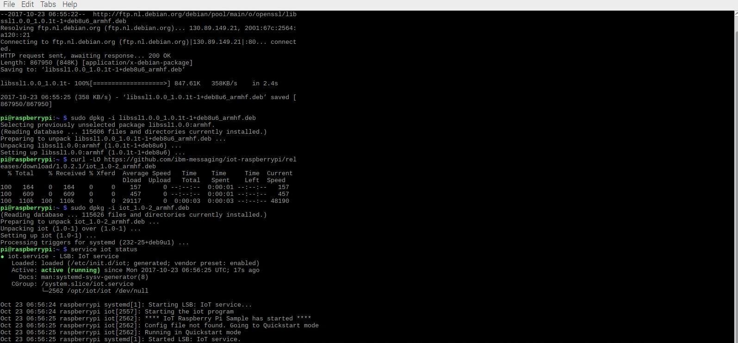

* Then open your terminal and type pip install ibmiotf

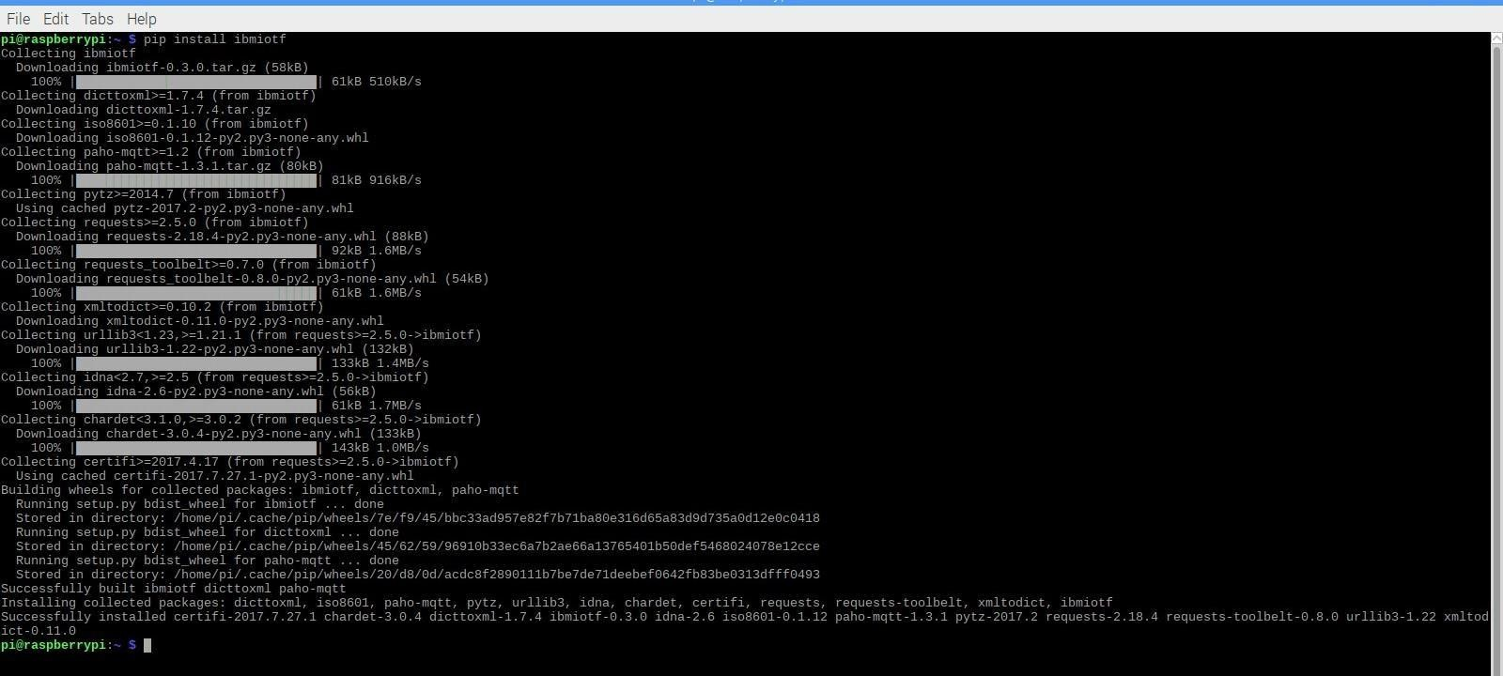

* I have sent DHT-11 Sensors data to ibm bluemix .To get the code u need to login into IOT GYAN.
* Then I get the image as follows in my pi’s shell:

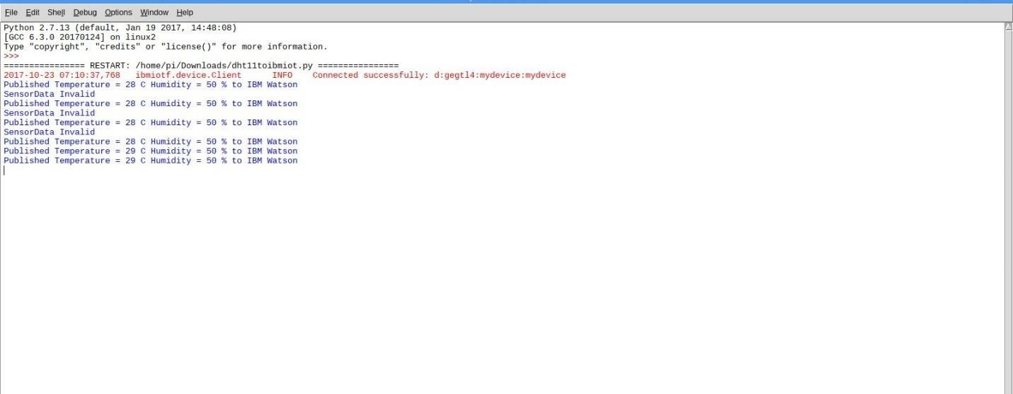

# Step-3: checking your data sent on IBM Bluemix:

* After you have sent your sensors data you can check whether it is received at your iot platform Just look at the image below and if u see the same wifi kind of symbol on your created device then your data is being received.



* After double clicking on your created device you can see the received data as shown in image

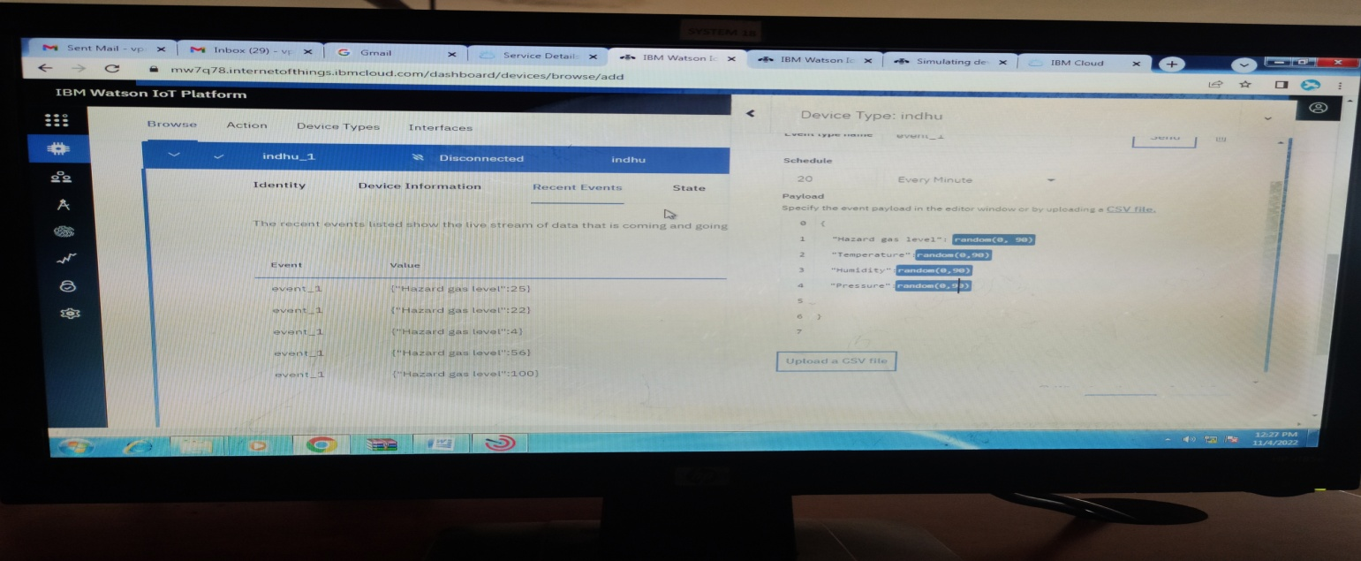

# Step-4: Creating boards and cards for visualization of data:

* In your Watson platform you have an option called board .Click on it and you get the following window on your screen

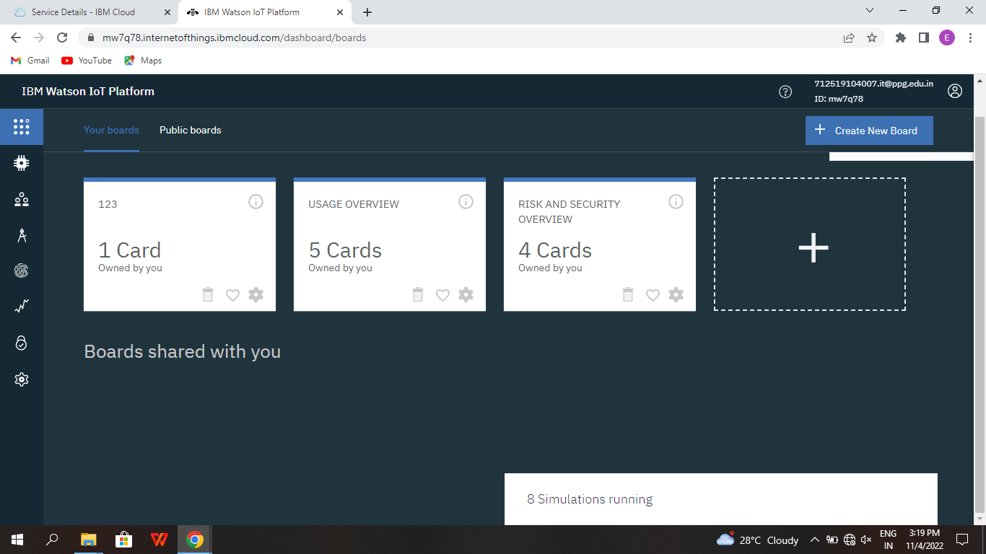

* Click on Create a new board to create a board .

The given below window appears give a name and description to your board as shown in the window below.

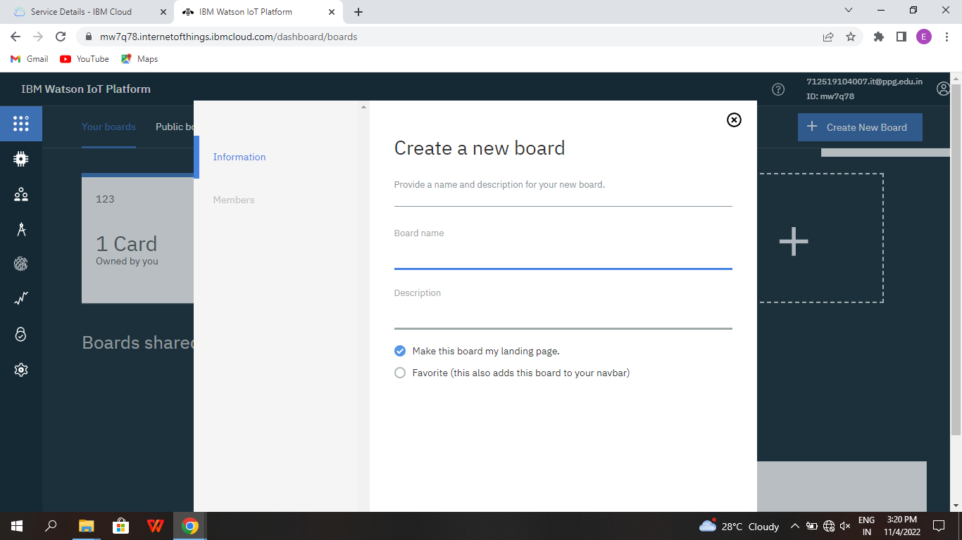

* Then click on Next you get the below window then again click on Submit

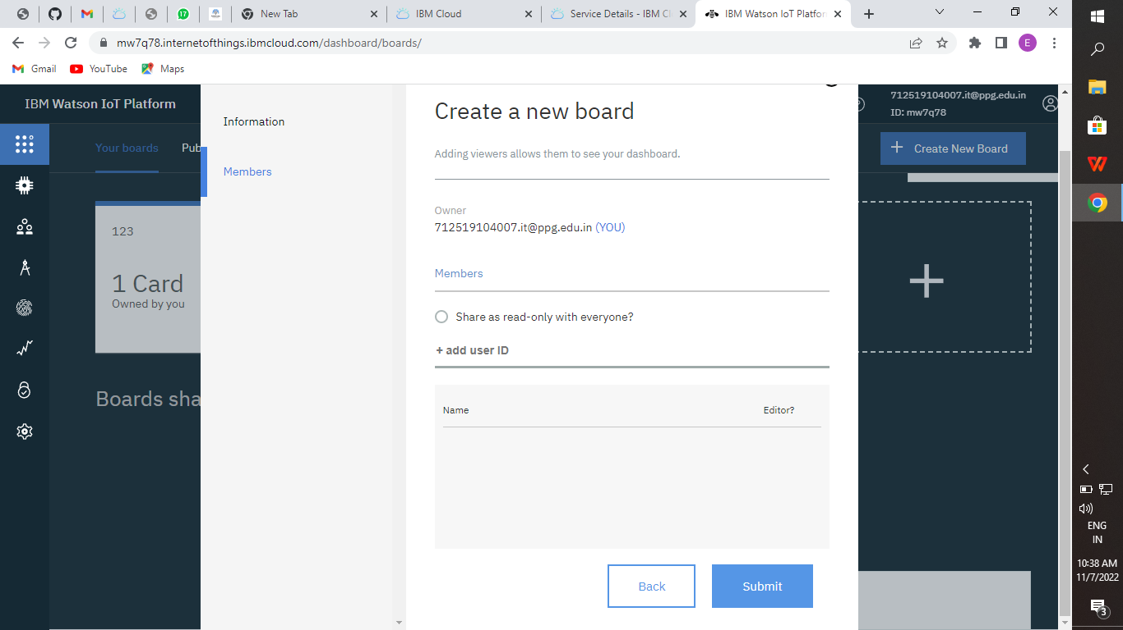

* Then double click on your boards name which you have created.



* Click on Add New Card

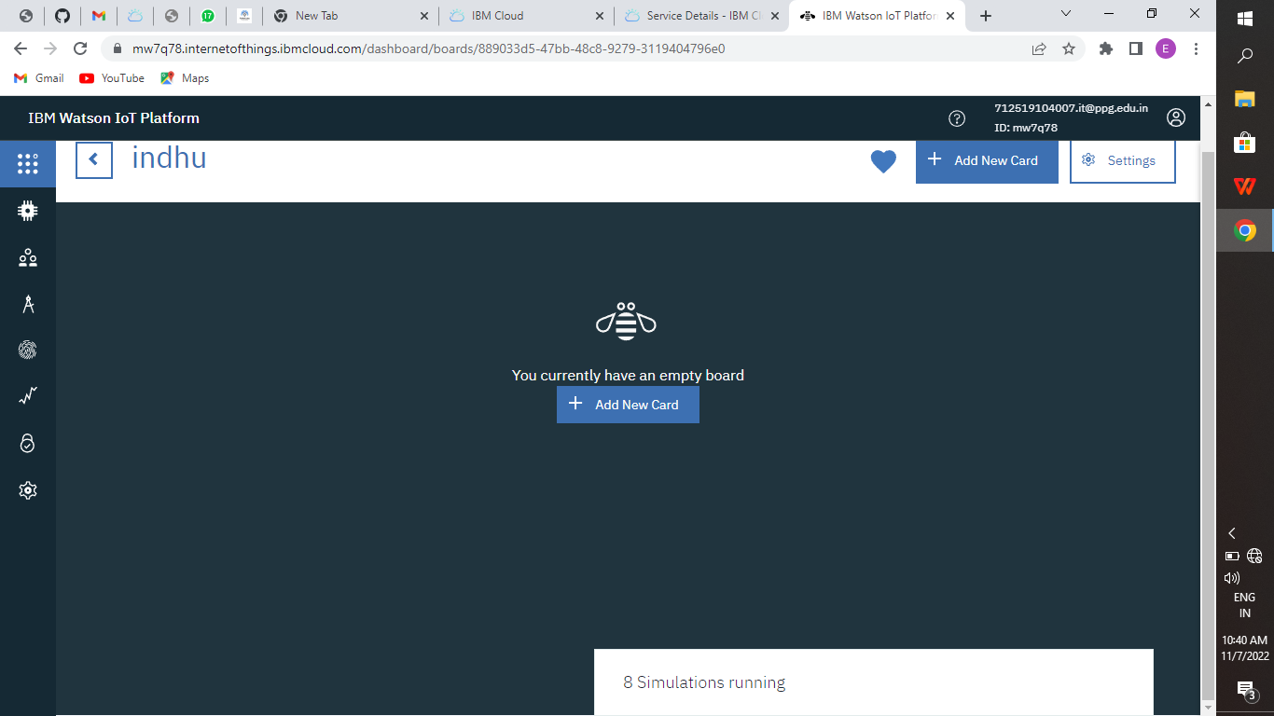

* Select the type of Graph u want accordingly and click next

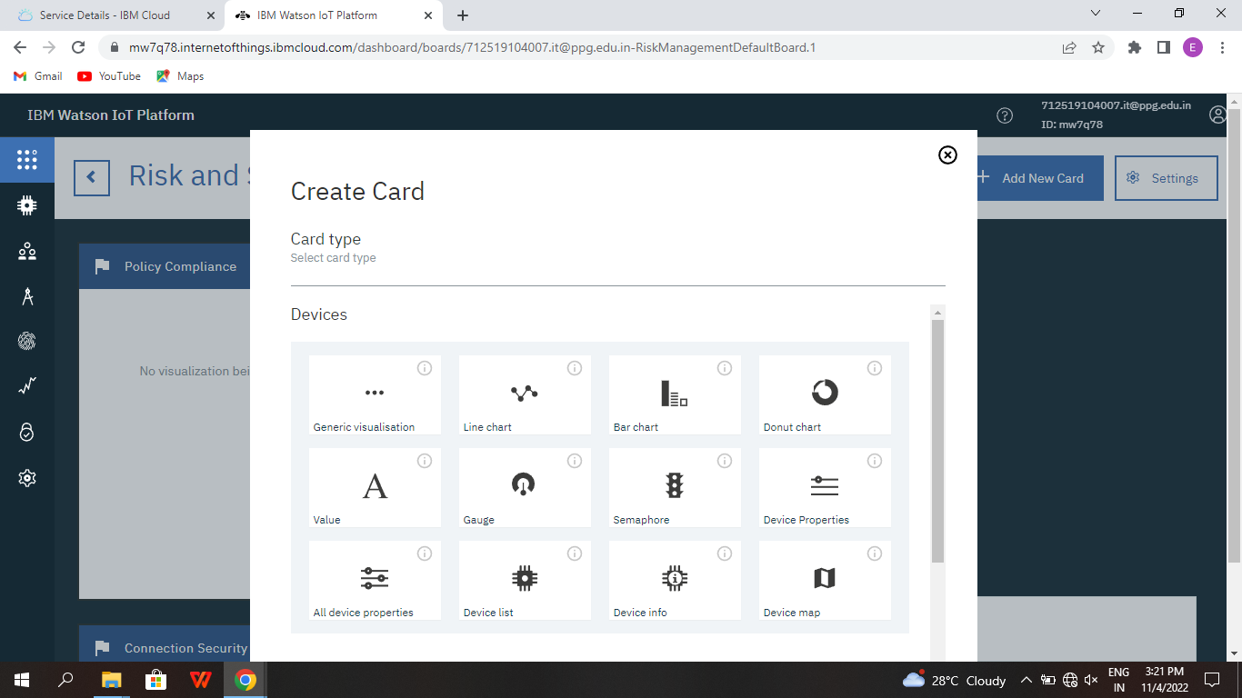

* You get the below window, choose the Device and click on Next.

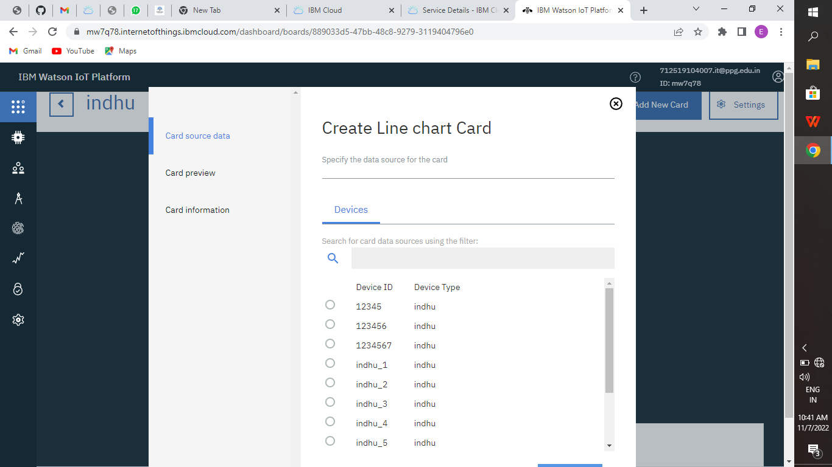

* Select the event, properly to be visualized on your graph and click next. In my case it is humidity

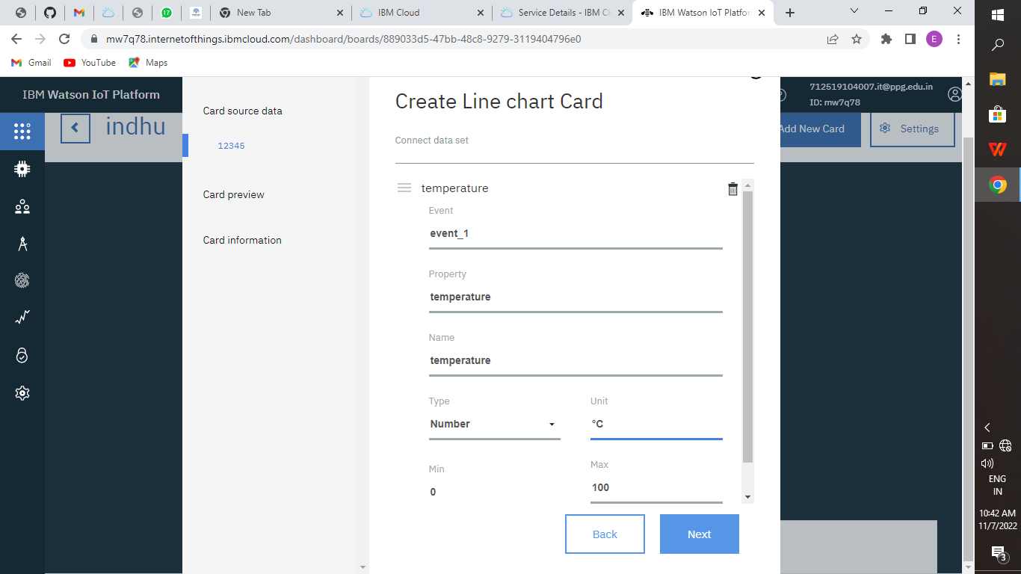

* Then select the size of the graph and color of the graph board you want and click next

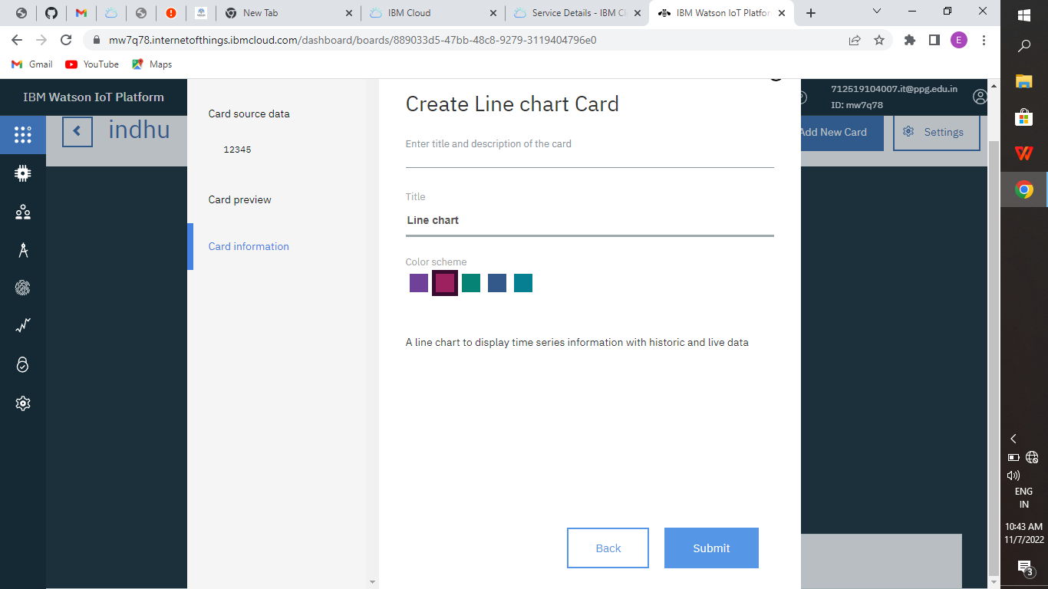

* Here is the graph

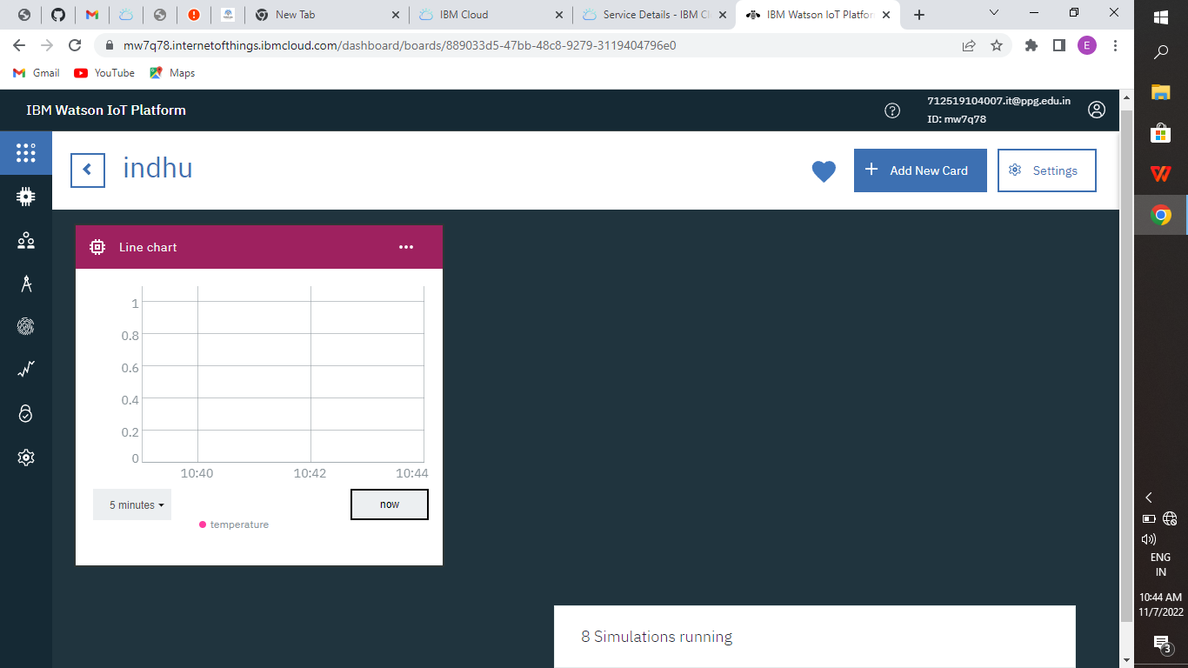

* Repeat the process to get different graphs.

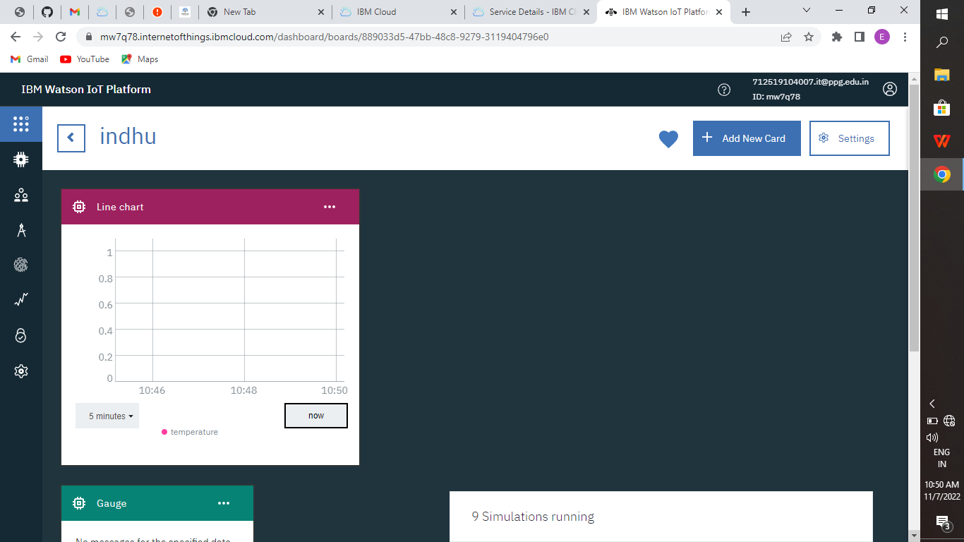



# RESULT:

Hence, we were able to send data from our pi to IBM Watson and visualize it on a graph.